Working with DotSpatial Symbology and Attribute Table
  - Tutorial (2)
Purpose of this tutorial: Become familiar with DotSpatial symbology, attribute table filter operations.
This tutorial has 5 important steps.
Step 1: Download the DotSpatial class library
Step 2: Add the DotSpatial reference and change the compile option.
Step 3: Add the DotSpatial Controls into the Visual Studio Toolbox.
Step 4: Design the GUI. (GUI - Graphical User Interface)
Step 5: Write the code for implementing the map operations.
Step 1: Download the DotSpatial class library
This step is the same as the Tutorial #1 step 1.
Step 2: Add the DotSpatial reference and change the compile option.
2.1) Add the required DotSpatial reference in the visual studio development environment.
Create a new VB or C# application and right click over the project on the solution explorer. On the context menu select the add reference and add the following reference from the DotSpatial folder.
DotSpatial.Controls, DotSpatial.Data, DotSpatial.Data.Forms, DotSpatial.Serialization, DotSpatial.Symbology, DotSpatial.Topology.
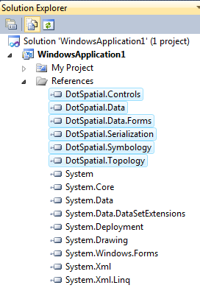
fig.1. (Required DotSpatial.dlls)

2.2) Change the compile option from .Net FrameWork 4 Client Profile to .Net FrameWork 4
This step is the same as the Tutorial # 1 step 2.2.
Step 3: Add the DotSpatial Controls into the Visual Studio Toolbox.
This step is the same as the Tutorial # 1 step 3.
Step 4: Design the GUI. (Graphical User Interface)
Design the GUI as follows:
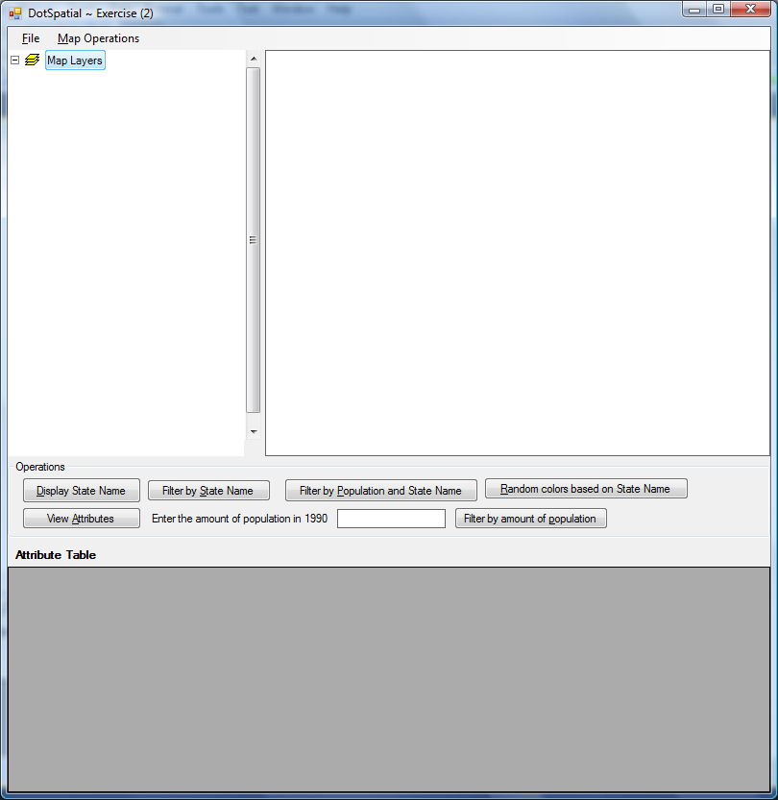
fig.2. (Graphical User Interface)
Interface design considerations.
1. Add a MenuStrip control on the form. Menu should contains the following menu items.
1.1 ) Main menu items : File, MapOperation
1.2) Sub menu items :
Under File menu item create 3 sub menu items as follows:
Load Map - Shortcut key should be "Control key + L"
Clear Map - Shortcut key should be "Control key + C"
Exit - Shortcut key should be "Control key + E"
Under Map Operations menu items create 3 sub menu items as follows:
Zoom In - Shortcut key should be "Control key + Up arrow"
Zoom out - Shortcut key should be "Control key + Down arrow"
Zoom Extent - Shortcut key should be "Control key + Z"
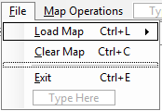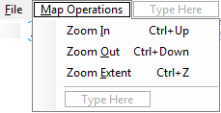
fig.3. (Menu Items on the form)
Note : For implementing shortcut key with alt and letters, you need to add the "&" sign in front of the letters. Example: File menu can access by pressing "Alt" + F key. Adding "&" sign in front of letter F is used implement this feature.
2. Add the SplitContainer controls on the form.
2.1 ) Add a SplitContainer control on the form. Set the property of the SplitContainer control as follows:
Name : splcMapLegend , Orientation : Vertical, Dock : Top
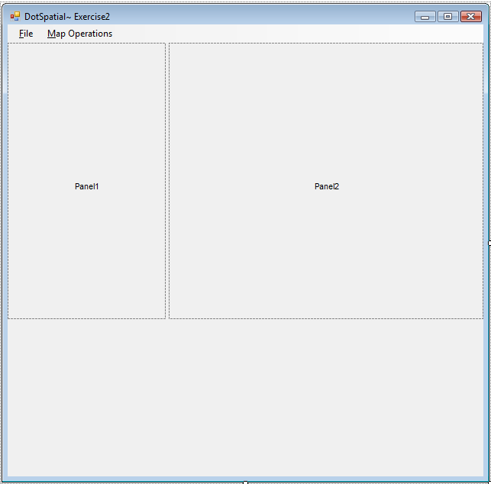
fig.4. (First SplitContainer control on the form)
2.2 ) Add one more SplitContainer control in the same form on the empty space (below the above SplitContainter control) . Set the property of the second SplitContainer control as follows:
Name : splcDataOpeation , Orientation : Horizontal , Dock : Fill
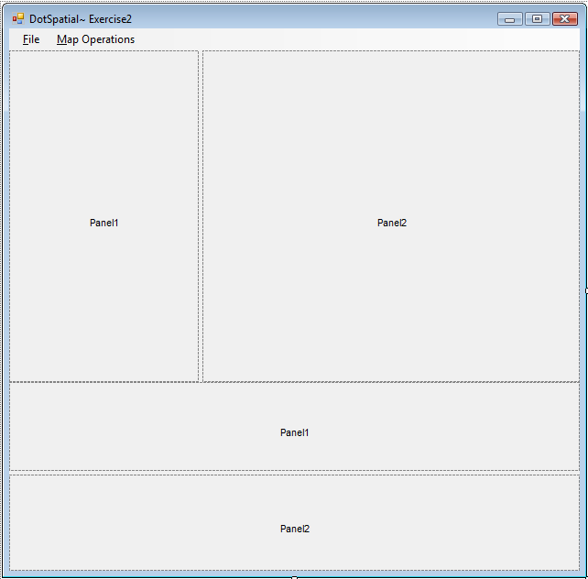
fig.4. (Both SplitContainers control on the form)
2. Add the Map and legend controls on the form.
2.1 ) Add the map control on the splcMapLegend control's panel 2 region and add legend control on the same control's panel1 region.
Map, Legend control are located on the Toolbox under DotSpatial controls.
Set the map properties as follows: Dock = Fill, Legend = Legend1, FunctionMode = Pan
Set the legend properties as follows: Dock = Fill
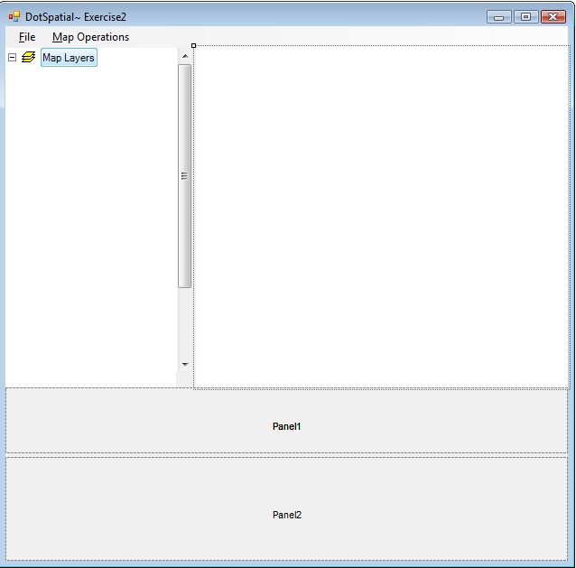
Map Control
Legend Control
fig.5. (Map and legend controls on the form)
3. Add a DataGridView and button controls on the form.
3.1 ) Add a DataGridView on the form: DataGridView is located under Data tab of the toolbox window. Add a DataGridView on the splcDataOpeation control's panel2 and set its property as follows:
Name = dgvAttributeTable , Dock = fill
3.2 ) Add a GroupBox control on the splcDataOpeation control's panel1 and set its property as follows:
Name = gbOperations , Text = Operations, Dock = Fill
3.3) Add the buttons and other controls.
Controls | Name | Text
Button | btnDisplayStateName | &Display State Name
Button | btnFilterByStateName | Filter by &State Name
Button | btnFilterByPopState | Filter by &Population and State Name
Button | btnRandomColors | &Random colors based on State Name
Button | btnViewAttributes | View &Attributes
Button | btnFilterByPopulation | Filter by amount of &population
Label | lblPopulation | Enter the amount of population in 1990
TextBox | txtPopulation
Label | lblTitle | Attribute Table

Final GUI should look as follows:
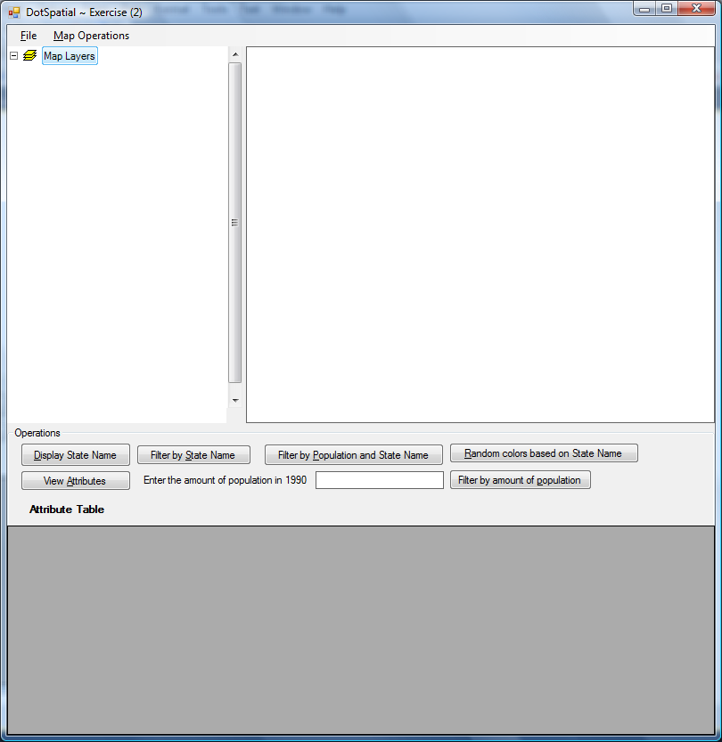
fig.6. (Final GUI)
Step 5: Write the code for implementing the map operations.
5.1) Add the following namespaces.
VB
'Required namespaces
Imports DotSpatial.Controls
Imports DotSpatial.Symbology

C#
// Required namespaces
using DotSpatial.Controls;
using DotSpatial.Symbology;

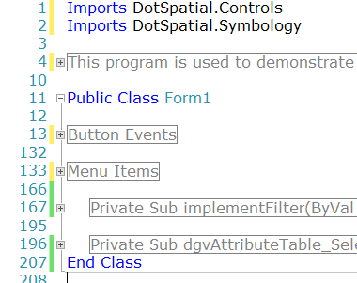
fig.7. (Mandatory NameSpaces)

5.2) Menu Item code implementation
5.2.1) Load a map
VB
Private Sub LoadMapToolStripMenuItem_Click(ByVal sender As System.Object, ByVal e As System.EventArgs) Handles LoadMapToolStripMenuItem.Click
'AddLayer() method is used to add a shape file in the MapControl
Map1.AddLayer()
End Sub

C#
private void LoadMapToolStripMenuItem_Click(object sender, EventArgs e)
{
//AddLayer() method is used to add a shape file in the MapControl.
Map1.AddLayer();
}

5.2.2) Clear the map
VB
Private Sub ClearMapToolStripMenuItem_Click(ByVal sender As System.Object, ByVal e As System.EventArgs) Handles ClearMapToolStripMenuItem.Click
Map1.Layers.Clear()
End Sub

C#
private void ClearMapToolStripMenuItem_Click(object sender, EventArgs e)
{
//Clear() method is used to clear the layers from the map control.
Map1.Layers.Clear();
}

5.2.3) Exit the application
VB
Private Sub ExitToolStripMenuItem_Click(ByVal sender As System.Object, ByVal e As System.EventArgs) Handles ExitToolStripMenuItem.Click
'Confirm with users that are they ready to close application or not with the help of message box.
If (MessageBox.Show("Do you want to close this application?", "Admin", MessageBoxButtons.OKCancel) = DialogResult.OK) Then
'Close() method is used to close the application
Me.Close()
End If
End Sub

C#
private void ExitToolStripMenuItem_Click(object sender, EventArgs e)
{
// Confirm with users that they are ready to close application or not with the help of message box.
if (MessageBox.Show("Do you want to close this application?", "Admin", MessageBoxButtons.OKCancel) == DialogResult.OK)
{
//Close() method is used to close the application.
this.Close();
}
}

5.2.4) Zoom in, Zoom Out, ZoomToMaxExtent and Clear map

VB
Private Sub ZoomInToolStripMenuItem_Click(ByVal sender As System.Object, ByVal e As System.EventArgs) Handles ZoomInToolStripMenuItem.Click
Map1.ZoomIn()
End Sub

Private Sub ZoomOutToolStripMenuItem_Click(ByVal sender As System.Object, ByVal e As System.EventArgs) Handles ZoomOutToolStripMenuItem.Click
Map1.ZoomOut()
End Sub

Private Sub ZoomExtentToolStripMenuItem_Click(ByVal sender As System.Object, ByVal e As System.EventArgs) Handles ZoomExtentToolStripMenuItem.Click
Map1.ZoomToMaxExtent()
End Sub

Private Sub ClearMapToolStripMenuItem_Click(ByVal sender As System.Object, ByVal e As System.EventArgs) Handles ClearMapToolStripMenuItem.Click
Map1.Layers.Clear()
End Sub

C#
private void zoomInToolStripMenuItem_Click(object sender, EventArgs e)
{
map1.ZoomIn();
}

private void zoomOutToolStripMenuItem_Click(object sender, EventArgs e)
{
map1.ZoomOut();
}

private void zoomExtentToolStripMenuItem_Click(object sender, EventArgs e)
{
map1.ZoomToMaxExtent();
}
private void clearMapToolStripMenuItem_Click(object sender, EventArgs e)
{
map1.Layers.Clear();
}

5.3) Implementing the attribute table filter operations and symbology
5.3.1) Displaying the attribute values on the shape file.
This example is used to display the state names on the shape file.
VB
Private Sub btnDisplayStateName_Click(ByVal sender As System.Object, ByVal e As System.EventArgs) Handles btnDisplayStateName.Click

'Check the number of layers from MapControl
If Map1.Layers.Count > 0 Then
'Declare a MapPolygonLayer
Dim stateLayer As MapPolygonLayer
'TypeCast the first layer from MapControl to MapPolygonLayer.
'Layers are 0 based, therefore 0 is going to grab the first layer from the MapControl
stateLayer = CType(Map1.Layers(0), MapPolygonLayer)

'Check whether stateLayer is polygon layer or not
If stateLayer Is Nothing Then
MessageBox.Show("The layer is not a polygon layer.")
Else
'add StateName as labels on the stateLayer
'[STATE_NAME] is an attribute from the given example US States shape file.
Map1.AddLabels(stateLayer, "[STATE_NAME]", New Font("Tahoma", 8.0), Color.Black)

End If
Else
MessageBox.Show("Please add a layer to the map.")
End If

End Sub

C#
private void btnDisplayStateName_Click(object sender, EventArgs e)
{
//Check the number of layers from MapControl
if (Map1.Layers.Count > 0)
{
//Declare a MapPolygonLayer
MapPolygonLayer stateLayer = default(MapPolygonLayer);

//TypeCast the first layer from MapControl to MapPolygonLayer.
//Layers are 0 based, therefore 0 is going to grab the first layer from the MapControl
stateLayer = (MapPolygonLayer)Map1.Layers[0];

//Check whether stateLayer is polygon layer or not
if (stateLayer == null)
{
MessageBox.Show("The layer is not a polygon layer.");
}
else
{
//add StateName as labels on the stateLayer
//[STATE_NAME] is an attribute from the given example US States shape file.
Map1.AddLabels(stateLayer, "[STATE_NAME]", new Font("Tahoma", (float)8.0), Color.Black);
}
}
else
{
MessageBox.Show("Please add a layer to the map.");
}
}

5.3.2) Displaying a specific state on the Map based on "SelectByAttribute" method

In this example Idaho State will be highlighted on the map.

VB
Private Sub btnFilterByStateName_Click(ByVal sender As System.Object, ByVal e As System.EventArgs) Handles btnFilterByStateName.Click
'Check the number of layers from MapControl
If Map1.Layers.Count > 0 Then
'Declare a MapPolygonLayer
Dim stateLayer As MapPolygonLayer
'TypeCast the first layer from MapControl to MapPolygonLayer.
'Layers are 0 based, therefore 0 is going to grab the first layer from the MapControl
stateLayer = TryCast(Map1.Layers(0), MapPolygonLayer)
'Check whether stateLayer is polygon layer or not
If stateLayer Is Nothing Then
MessageBox.Show("The layer is not a polygon layer.")
Else
'SelectByAttribute method is used to implement the filter operations.
'In this example, STATE_NAME is used implement the filter operation
'We can see the IdhoSate on the map
stateLayer.SelectByAttribute("[STATE_NAME] = 'Idaho'")
End If
Else
MessageBox.Show("Please add a layer to the map.")
End If
End Sub

C#
private void btnFilterByStateName_Click(object sender, EventArgs e)
{
//Check the number of layers from MapControl
if (Map1.Layers.Count > 0)
{
//Declare a MapPolygonLayer
MapPolygonLayer stateLayer = default(MapPolygonLayer);

//TypeCast the first layer from MapControl to MapPolygonLayer.
//Layers are 0 based, therefore 0 is going to grab the first layer from the MapControl
stateLayer = (MapPolygonLayer)Map1.Layers[0];

//Check whether stateLayer is polygon layer or not
if (stateLayer == null)
{
MessageBox.Show("The layer is not a polygon layer.");
}
else
{
//SelectByAttribute method is used to implement the filter operations.
//In this example, STATE_NAME is used implement the filter operation
//We can see the IdhoSate on the map
stateLayer.SelectByAttribute("[STATE_NAME] = 'Idaho'");
}
}
else
{
MessageBox.Show("Please add a layer to the map.");
}
}

5.3.3) Implementing a filter operation for more than one attribute from the attribute table.

In this example, two attributes will be filtered and the result will be highlighted on the map.

VB
Private Sub btnFilterByPopState_Click(ByVal sender As System.Object, ByVal e As System.EventArgs) Handles btnFilterByPopState.Click
'check the number of layers from map control
If Map1.Layers.Count > 0 Then

'Delacre a MapPolygonLayer
Dim stateLayer As MapPolygonLayer

'Type cast the FirstLayer of MapControl to MapPolygonLayer
stateLayer = TryCast(Map1.Layers(0), MapPolygonLayer)

'Check the MapPolygonLayer ( Make sure that it has polygon layer or not)
If stateLayer Is Nothing Then
MessageBox.Show("The layer is not a polygon layer.")
Else

'!!! this line is necessary otherwise the code doesn't work
'this will load the attribute table of the layer into memory.
stateLayer.DataSet.FillAttributes()

'Create a new PolygonScheme
Dim scheme As New PolygonScheme

'Create a new PolygonCategory
Dim category As New PolygonCategory(Color.Yellow, Color.Red, 1)

'Declare a filter string
'[POP1990],[STATE_NAME] are attributes from the attribute table of the given shape file.

Dim filter As String = "[POP1990] < 2000000 OR [STATE_NAME] = 'Idaho'"

'Set/Assign the filter expression to PolygonCategory
category.FilterExpression = filter

'Set the lagendText
category.LegendText = "population < 2 Million"

'Add the PolygonCategory in to the PolygonScheme
scheme.AddCategory(category)

'Set the scheme in to the MapPolygonLayer's symbology
stateLayer.Symbology = scheme

End If
Else
MessageBox.Show("Please add a layer to the map.")
End If
End Sub

C#
private void btnFilterByPopState_Click(object sender, EventArgs e)
{
//check the number of layers from map control

if (Map1.Layers.Count > 0)
{
//Delacre a MapPolygonLayer
MapPolygonLayer stateLayer = default(MapPolygonLayer);

//Type cast the FirstLayer of MapControl to MapPolygonLayer
stateLayer = (MapPolygonLayer)Map1.Layers[0];

//Check the MapPolygonLayer ( Make sure that it has a polygon layer)
if (stateLayer == null)
{
MessageBox.Show("The layer is not a polygon layer.");

}
else
{
//!!!-------------------- this line is necessary otherwise the code doesn't work------------------------!!!!!!!!!!!!!!!!!!!!
//this will load the attribute table of the layer into memory.
stateLayer.DataSet.FillAttributes();

//Create a new PolygonScheme
PolygonScheme scheme = new PolygonScheme();

//Create a new PolygonCategory
PolygonCategory category = new PolygonCategory(Color.Yellow, Color.Red, 1);

//Declare a filter string
//[POP1990],[STATE_NAME] are attributes from the attribute table of the given shape file.

string filter = "[POP1990] > 10000000 OR [STATE_NAME] = 'Idaho'";

//Set/Assign the filter expression to PolygonCategory
category.FilterExpression = filter;

//Set the Legend Text
category.LegendText = "population > 10 Million";

//Add the PolygonCategory in to the PolygonScheme
scheme.AddCategory(category);

//Set the scheme in to the MapPolygonLayer's symbology
stateLayer.Symbology = scheme;
}
}
else
{
MessageBox.Show("Please add a layer to the map.");
}
}

5.3.4) Set the random colors based on the unique values from an attribute table's column.

VB
Private Sub btnRandomColors_Click(ByVal sender As System.Object, ByVal e As System.EventArgs) Handles btnRandomColors.Click
'check the number of layers from map control
If Map1.Layers.Count > 0 Then
'Delacre a MapPolygonLayer
Dim stateLayer As MapPolygonLayer
'Type cast the FirstLayer of MapControl to MapPolygonLayer
stateLayer = CType(Map1.Layers(0), MapPolygonLayer)
'Check the MapPolygonLayer ( Make sure that it has a polygon layer)
If stateLayer Is Nothing Then
MessageBox.Show("The layer is not a polygon layer.")
Else
'Create a new PolygonScheme
Dim scheme As New PolygonScheme
'Set the ClassificationType for the PolygonScheme via EditotSettings
scheme.EditorSettings.ClassificationType = ClassificationType.UniqueValues
'Set the UniqueValue field name
'Here STATE_NAME would be the Unique value field
scheme.EditorSettings.FieldName = "STATE_NAME"
'create categories on the scheme based on the attributes table and field name
'In this case field name is STATE_NAME
scheme.CreateCategories(stateLayer.DataSet.DataTable)
'Set the scheme to stateLayer's symbology
stateLayer.Symbology = scheme
End If
Else
MessageBox.Show("Please add a layer to the map.")
End If
End Sub

C#
private void btnRandomColors_Click(object sender, EventArgs e)
{
//check the number of layers from map control
if (Map1.Layers.Count > 0)
{
//Delacre a MapPolygonLayer
MapPolygonLayer stateLayer = default(MapPolygonLayer);

//Type cast the FirstLayer of MapControl to MapPolygonLayer
stateLayer = (MapPolygonLayer)Map1.Layers[0];

//Check the MapPolygonLayer ( Make sure that it has a polygon layer)
if (stateLayer == null)
{
MessageBox.Show("The layer is not a polygon layer.");
}
else
{
//Create a new PolygonScheme
PolygonScheme scheme = new PolygonScheme();

//Set the ClassificationType for the PolygonScheme via EditorSettings
scheme.EditorSettings.ClassificationType = ClassificationType.UniqueValues;

//Set the UniqueValue field name
//Here STATE_NAME would be the Unique value field
scheme.EditorSettings.FieldName = "STATE_NAME";

//create categories on the scheme based on the attributes table and field name
//In this case field name is STATE_NAME
scheme.CreateCategories(stateLayer.DataSet.DataTable);

//Set the scheme to stateLayer's symbology
stateLayer.Symbology = scheme;
}
}
else
{
MessageBox.Show("Please add a layer to the map.");
}

}

5.3.5) Filtering the data from shape file during the run time. User can enter the filter amount of population via the interface.

VB
''' <summary>
''' This method is used filter the attribute table of the shapefile based on the population in 1990.
''' </summary>
''' <param name="population">Amount of population in 1990</param>
''' <remarks>No return value</remarks>
Private Sub filterbyPopulation (ByVal population As Integer)
If Map1.Layers.Count > 0 Then
Dim stateLayer As MapPolygonLayer
stateLayer = CType(Map1.Layers(0), MapPolygonLayer)
If stateLayer Is Nothing Then
MessageBox.Show("The layer is not a polygon layer.")
Else

'!!! this line is necessary otherwise the code doesn't work
'this will load the attribute table of the layer into memory.
stateLayer.DataSet.FillAttributes()

Dim scheme As New PolygonScheme
Dim category As New PolygonCategory(Color.Yellow, Color.Red, 1)
Dim filter As String = "[POP1990] < " & population & ""

category.FilterExpression = filter
category.LegendText = "population < " + population.ToString()
scheme.AddCategory(category)

stateLayer.Symbology = scheme
End If
Else
MessageBox.Show("Please add a layer to the map.")
End If
End Sub

C#
/// <summary>
/// This method is used filter the attribute table of the shapefile based on the population in 1990.
/// </summary>
/// <param name="population">Amount of population in 1990</param>
/// <remarks>No return value</remarks>
private void filterbyPopulation(int population)
{
if (Map1.Layers.Count > 0)
{
MapPolygonLayer stateLayer = default(MapPolygonLayer);

stateLayer = (MapPolygonLayer)Map1.Layers[0];

if (stateLayer == null)
{
MessageBox.Show("The layer is not a polygon layer.");
}
else
{
//!!! this line is necessary otherwise the code doesn't work
//this will load the attribute table of the layer into memory.
stateLayer.DataSet.FillAttributes();

PolygonScheme scheme = new PolygonScheme();

PolygonCategory category = new PolygonCategory(Color.Yellow, Color.Red, 1);

string filter = "[POP1990] < " + population + "";

category.FilterExpression = filter;

category.LegendText = "population < " + population.ToString();

scheme.AddCategory(category);

stateLayer.Symbology = scheme;
}
}
else
{
MessageBox.Show("Please add a layer to the map.");
}
}

Call the above method in the btnFilterByPopulation button click event.

VB
Private Sub btnFilterByPopulation_Click(ByVal sender As System.Object, ByVal e As System.EventArgs) Handles btnFilterByPopulation.Click
'Call the implementFilter method.
'We need to pass an interger intput paramter,
' Therefore, I just implemented integer typecasting.
Dim number As Double
'Validating the textbox input.
If String.IsNullOrEmpty(txtPopulation.Text) OrElse Not Double.TryParse(txtPopulation.Text, number) Then
MessageBox.Show("Please enter a valid value", "Admin", MessageBoxButtons.OK, MessageBoxIcon.Warning)
txtPopulation.Text = ""
Else
'Call the implementFilter method.
'We need to pass an interger intput paramter,
' Therefore, I just implemented integer typecasting.
filterbyPopulation(Convert.ToInt32(txtPopulation.Text.ToString()))
End If

End Sub

C#
private void btnFilterByPopulation_Click(object sender, EventArgs e)
{
double number;
//Validating the textbox input.
if (string.IsNullOrEmpty(txtPopulation.Text) || !double.TryParse(txtPopulation.Text, out number))
{
MessageBox.Show("Please enter a valid value", "Admin", MessageBoxButtons.OK, MessageBoxIcon.Warning);
txtPopulation.Text = "";
}
else
{
//Call the filterbyPopulation method.
//We need to pass an interger intput paramter,
// Therefore, I just implemented integer typecasting.
filterbyPopulation(Convert.ToInt32(txtPopulation.Text.ToString()));
}

}

4.3.7) Displaying the attribute table on a DataGridView.
VB
Private Sub btnViewAttributes_Click(ByVal sender As System.Object, ByVal e As System.EventArgs) Handles btnViewAttributes.Click
'Declare a datatable
Dim dt As DataTable
If Map1.Layers.Count > 0 Then
Dim stateLayer As MapPolygonLayer
stateLayer = CType(Map1.Layers(0), MapPolygonLayer)
If stateLayer Is Nothing Then
MessageBox.Show("The layer is not a polygon layer.")
Else
'Get the shapefile's attribute table to our datatable dt
dt = stateLayer.DataSet.DataTable
'Set the datagridview datasource from datatable dt
dgvAttributeTable.DataSource = dt
End If
Else
MessageBox.Show("Please add a layer to the map.")
End If
End Sub

C#
private void btnViewAttributes_Click(object sender, EventArgs e)
{
//Declare a datatable
DataTable dt = null;

if (Map1.Layers.Count > 0)
{
MapPolygonLayer stateLayer = default(MapPolygonLayer);

stateLayer = (MapPolygonLayer)Map1.Layers[0];

if (stateLayer == null)
{
MessageBox.Show("The layer is not a polygon layer.");
}
else
{
//Get the shapefile's attribute table to our datatable dt
dt = stateLayer.DataSet.DataTable;

//Set the datagridview datasource from datatable dt
dgvAttributeTable.DataSource = dt;
}
}
else
{
MessageBox.Show("Please add a layer to the map.");
}

}

4.3.8) Implementing DataGridView selection event
Based on the selection of the state from the DataGridView, state is highlighted on the map.
First of all, select the DataGridView on the GUI and select its property window. On the property window select the event tab.
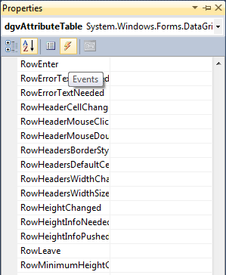
fig.8. (Events on Properties window)
On the event window, double click over the SelectionChanged event.
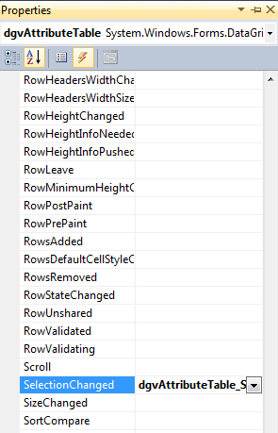
fig.9. (SelectionChanged on Properties window of DataGridView)
Under the dgvAttributeTable_SelectionChanged write the code as follows:
VB
Private Sub dgvAttributeTable_SelectionChanged(ByVal sender As System.Object, ByVal e As System.EventArgs) Handles dgvAttributeTable.SelectionChanged
For Each row As DataGridViewRow In dgvAttributeTable.SelectedRows
Dim stateLayer As MapPolygonLayer
stateLayer = CType(Map1.Layers(0), MapPolygonLayer)
If stateLayer Is Nothing Then
MessageBox.Show("The layer is not a polygon layer.")
Else
stateLayer.SelectByAttribute("[STATE_NAME] =" + "'" + row.Cells("STATE_NAME").Value + "'")
End If
Next
End Sub

C#
private void dgvAttributeTable_SelectionChanged(object sender, EventArgs e)
{
foreach (DataGridViewRow row in dgvAttributeTable.SelectedRows)
{
MapPolygonLayer stateLayer = default(MapPolygonLayer);

stateLayer = (MapPolygonLayer)Map1.Layers[0];

if (stateLayer == null)
{ MessageBox.Show("The layer is not a polygon layer."); }
else
{
stateLayer.SelectByAttribute("[STATE_NAME] =" + "'" + row.Cells["STATE_NAME"].Value + "'");
}
}
Final output would be as follows:

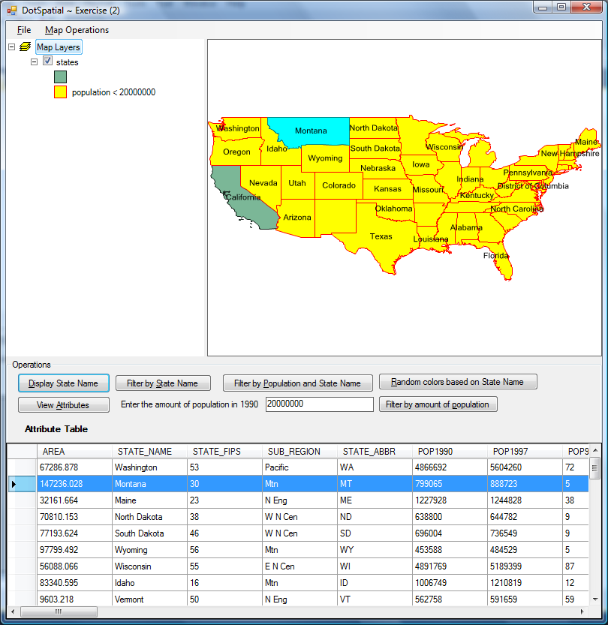
fig.10. (Final Output)

